The following Is a work developed by Members of Beyond Belief Seattle, a secular 12-Step recovery group. This Step Working Guide is not affiliated with any 12-Step fellowship. References to books and texts are suggestions only. Their identification is not an endorsement of, nor from, the identified fellowship(s).
There are limited options available for working a 12-Step program as a non-believer. This work is intended as a template, or foundation, with the user able to edit or adapt it to meet their personal needs.
This was never intended to be considered a completed project. There are now many different secular 12-Step groups worldwide, each with their own ideas on many aspects of delivering a secular program to their members. Early on, Beyond Belief Seattle imagined a larger group of members each contributing to the expansion of this work in pursuit of a more in-depth tool to help non-believers in their recovery.

A Secular Step Working Guide
A Non-Religious 12-Step Approach to Recovery

Developed by the members of
Beyond Belief Seattle
Seattle & Everett WA Areas

Meeting Monday Night 7:30pm
Lakeside Milam
7935 Lake Ballinger Way, Edmonds, WA 98026

Working Draft #3
January 2021

Please do not copy or disseminate without first checking with the Beyond Belief Seattle Group
bbeliefseattle@gmail.com

Secular 12 Steps

from the Beyond Belief Seattle Group (Seattle & Everett, WA)

Step One: “Admitted we were powerless over our addiction and that our lives had become unmanageable.”

Step Two: “Came to believe the wisdom of the program and its members could restore us to sanity.”

Step Three: “We made a decision to follow a path of recovery.”

Step Four: “We made a searching, fearless, and honest inventory of ourselves.”

Step Five: “We admitted to ourselves and to another human being the exact nature of our wrongs.”

Step Six: “We became entirely ready to remove our defects of character.”

Step Seven: “With the assistance of others and our own firm resolve, we transform negative aspects of ourselves and cultivate positive ones.”

Step Eight: “We made a list of all persons we had harmed and became willing to make amends to them all.”

Step Nine: “We made direct amends to such people wherever possible, except when to do so would injure them or others.”

Step Ten: “We continued to take personal inventory and when we were wrong promptly admitted it.”

Step Eleven: “We sought through meditation to improve our conscious contact with our highest selves and to find integrity in all areas of our lives.”

Step Twelve: “Having had an awakening as a result of these steps, we tried to carry this message to addicts and to practice these principles in all our affairs.”

Step One
“Admitted we were powerless over our addiction and that our lives had become unmanageable.”
Part 1
1. It is suggested to read Step One out of the NA Basic Text 6th Edition every day before reflecting and writing.
2. It is suggested to read Step One out of It Works, How and Why (if available).
3. Reflect and write about what each of the following parts means to you:
- We admitted
- that we were Powerless
- over our Addiction
- and that our lives
- had become Unmanageable
4. What is the principle of Step One?
5. Every day, write on recent events that caused you to have strong feelings today or from the past. Write about the circumstances leading up to the event, the event itself, and the consequences arising from the event, be they good or bad.
6. Look up “control.” Reflect and write about what part your need to “control” played in these events.
7. Look up “surrender.” Reflect and write about how an attitude of “surrender” may have helped in the present, past, or future.

- - - - - - - - - - - - - - - - - -
“Admitted we were powerless over our addiction and that our lives had become unmanageable.”
One of the longest bridges we will ever cross in recovery is the one between the two parts of Step One. Our starting point is first recognizing that we are powerlessness, that our addiction drives every aspect of our lives (the physical, mental, and emotional). However, this recognition is only the beginning of Step One. We also must “cross over” in order to realize that we are not only powerless in our addiction, but that is also makes our lives unmanageable. In making this connection between the powerlessness and unmanageability of addiction, we have crossed the first bridge on the road to recovery.
A first mistake that many of us make when we come into the program is that we think drugs are the problem. It’s not the drugs – it’s the addiction. When we say to someone that drugs are only a symptom of a much deeper problem (addiction), it is sometimes hard for them to understand this.
To get a better understanding of addiction, we must look at the concept of addiction as a disease. From that point of view, addiction is a disease of attitudes, personality and a general negative outlook rooted in fear, insecurity and low self-esteem. The main ingredients of addiction are obsession and compulsion.
Obsession is that fixed idea that takes us back time and time again to our particular drug or some substitute, (substitute being anything that makes us feel good and gets instant gratification; such as, money, power, sex, food, anger, etc.) to recapture the illusion of ease and comfort we once knew. Once starting the process with one fix, one pill, one drink or one substitute, compulsion is being unable to stop through our own power of will. Because of our physical sensitivity to drugs and anything that makes us feel good, we are completely in the grip of a destructive power greater then ourselves.
Looking at addiction from this point of view, we see how addiction makes our lives unmanageable with or without drugs. In this First Step of recovery, we must surrender and accept how powerless we are over our addiction. When we do this a very strange thing happens: we begin to gain power through the WE part of the program. The next eleven steps help us to develop and strengthen that power. It is often said that the First Step is our past and the things of our past. The next eleven steps are our future.
Now that we have a better understanding of our addiction, let us look at some ways we can apply the First Step in our daily lives. The most obvious way is that we don't pick up that first drug, pill or drink; otherwise our lives will become unmanageable all over again. Now, let's take a look at some NON-chemical ways we can apply this step in our lives:
- You go out to your car in the morning and it has a flat tire. Rather than feeding into the addictive attitudes of frustration or anger, which will create unmanageability, we must accept and surrender to the fact that the tire is flat and take action to correct the situation. As addicts we tend to resist the act of surrendering and to use this step on everyday problems, thus making our lives unmanageable.

- Another situation could be that you go out to your car, start it and the motor dies. It can't be fixed. You need it for your job. You must be able to apply the first step to this situation. Accepting and surrendering to the fact that the car cannot be fixed, you gain the power to go forward to find alternative transportation. You can refuse to surrender, refuse to apply the step and allow your life to become unmanageable. The choice is yours.
As you see, the first step can and must be applied in all areas of your life. This is called living the steps. The bottom line is drugs are but one symptom of our disease. The only relief we get from our disease is by working the steps. It is a new and exciting experience that will bring many changes into our lives.
One last thing that cannot be over-emphasized—the WE portion of these steps. These examples offered begin with the pronoun WE except the twelfth, which has the word WE in the center. Part of our strength and power in recovery comes from WE. Together we can. I can't, WE can! This is why we need meetings for the rest of our lives. This is why we need daily contact with other recovering addicts. Another thing many members think is, if I stop using I should be cured and I don't need the program or meetings anymore. As addicts we must remember: we were addicted long before we ever used. It is much easier to stay stopped than to stop, itself.
Part 2
You’ll notice that we are discussing the disease of addiction in broad terms as a whole, rather than your own particular manifestation of the disease. We’ll use this broad perspective to build a more complete understanding of how the disease manifests itself in you.
Reflect and write about the following questions on a separate sheet of paper and consider sharing it with your Sponsor, another member, or another person.
1. What is the disease of addiction?
2. Why is being clean not enough?
3. How was my life unmanageable in my addiction?
4. How is my life unmanageable in my recovery?
5. How do I apply the first step in my life?
6. Do I feel like there are obstacles in continuing working the steps, that I can see right now? If so, what are they?
7. Am I willing to accept the steps as a way of life?
8. What awakening of consciousness (if any) did you have as a result of this step?

Step Two
“Came to believe the wisdom of the program and its members could restore us to sanity.”
Part 1
1. It is suggested to read Step Two out of NA Basic Text (5th or 6th Edition) every day before reflecting and writing.
2. It is suggested to read Step Two out of It Works, How and Why (if available).
3. Write down your definition of each major word in the step. Then look up each word individually in a dictionary and reflect and write what you learn about the difference between what you thought the words meant and the dictionary definitions.
4. Reflect and write about your understanding of concept of insanity. Then look it up and write about what you have learned.
5. Write about your understanding of the concept of sanity. Then look it up and write about what you have learned.
6. Write about your understanding of the concept of faith. Then look it up and write about what you have learned.
7. Reflect and write about what each of the following parts means to you:
- We Came
- To Believe
- The wisdom
- Of the Program
- And it’s Members
- Could Restore us to Sanity
8. What is the principle of Step Two?
9. Write what a "Power Greater than Yourself" means to you.
10. Every day write about events that relate to "Making the same mistakes and expecting different results." Also write about events that a "Power Greater than Yourself" participated in your life.
- - - - - - - - - - - - - - - - - -
"We came to believe that the wisdom of the Program and its Members could restore us to sanity."
The insanity referred to in this step is not the insanity of using drugs. We were restored to sanity of not using drugs in Step One. We now find ourselves clean and our lives are still unmanageable in many areas. Much of that unmanageability comes from (as Einstein said), “doing the same thing over and over again, and expecting different results.” Of course the results were always the same: unmanageability and insanity in our lives. Ultimately, there is nothing left to do except go on the best we can or begin to change, and with the Second Step as our guide to ongoing recovery, we can change.
The next question we begin to ask is, "What is a power greater than ourselves?" In the Third Step a higher power is the ultimate power greater than ourselves, whatever our concept of a Higher Power is. This, however, is not the power greater than ourselves referred to in the Second Step. A power greater than ourselves is not a singular, fixed power. A power greater than ourselves can change from situation to situation. For many of us, a power greater than ourselves is the NA program itself—including the fellowship or group. But a power greater than ourselves can also be a sponsor, another person, pain, or something we may read, etc. It is anything that makes us aware of the insanity of a situation if we act out on a character defect or negative will.
Now that we have an understanding of the Second Step, let's take a look at some of the ways we can apply it in our lives:
- Again, the first way many of us applied this step when we came into the program was that the program becomes a power greater than ourselves. The program helps us get through early problems without using and teaches us different ways of doing things.
- Something someone may share with us can become a power greater than ourselves, if it makes us aware of something we are doing in the wrong way so we can change it.
- Pain may at times become a power greater than ourselves. Sometimes pain is the only thing that will make us do something in a different way to get sane results.
- A sponsor or some other recovering addict can become a power greater than ourselves, by making us aware of the way we are doing things.
You can see, now, how a power greater than ourselves can change from situation to situation. The important thing is to be aware of how to apply this principle in your life, so that insanity and unmanageability do not take hold. The principle of Step Two can be a power greater than ourselves in itself!

Part 2
Reflect and write about the following questions on a separate sheet of paper and consider sharing it with your Sponsor, another member, or another person.
1. What is a power greater than yourself?
2. What type of sanity is the Second Step referring to?
3. How can I apply this step in my life?
4. What does this step mean to me?
5. What awakening of understanding or consciousness (if any) did you have as a result of this step?

Step Three
“We made a decision to follow a path of recovery.”
Part 1
At first encounter, Step Three can be problematic for many addicts seeking a path to recover, particularly atheists, agnostics, or non-religious people. As written in many 12-step texts and self-help books, and practiced in many groups, Step Three refers to an acceptance of God and turning our will and lives over to his care. For some, this is a serious stumbling block to recovery, but it does not need to be so.
The Basic Text (6th Edition p. 25) says the following:
“Our concept of God comes not from dogma but from what we believe and from what works for us. Many of us understand God to be simply whatever force keeps us clean. The right to a God of your understanding is total and without any catches.”
Therefore, don’t get too hung up on the specific content of the readings. Depending on your personal beliefs and ideas around religion, feel free to use any of what you read in these texts, or to discard anything that doesn’t feel appropriate to you.
Our interpretation of Step Three is: “We made a decision to follow a path of recovery.”
1. Reflect and write about your concept of willingness. Then look it up and write about what you have learned.
2. Reflect and write about what each of the following parts means to you:
- We Made
- A Decision
- To follow
- a path of recovery
3. What does it mean to you, to follow a path of recovery?
4. Each day, write about any situations or events where you felt connected to a path of recovery.
5. What is the principle of Step Three?
- - - - - - - - - - - - - - - - - -
"We made a decision to follow a path of recovery."
As noted above, Step Three is often referred to as a stumbling block of recovery. Many of us just get stuck here and can't seem to move on. The reason is that as addicts, we like to take something simple and complicate it. It doesn't have to be that way, if we become willing and open minded.
With that in mind, let's take a look at this step beginning with the word "Decision." What is a decision? "Decision" is an action word. It is a beginning or a starting point. Looking at it from the point of view of the program, it is the time in our lives that we “let go” of our old attitudes as we make mistakes and grow in the practical sense. Being willing and open-minded is very important as far as "Decision" and the Third Step is concerned. Simply put, a decision is accepting this step into our lives, and putting this decision to action.
The next part of this step is "to follow a path of recovery". What does this mean? The answer will vary from one person to another. And the definition of this changes over time, as we continue along this path of recovery. For some in early recovery, this path has been defined and recommended as attending 90 meetings in 90 days. Later, the path might mean committing to attending a recovery-related function other than meetings that we’ve been hesitant to attend, or accepting a service position. Still later, it might include starting step work with a sponsor, or joining a step working group.
Along the way our attitudes might change on how we deal with other members. The path to recovery might include giving someone the benefit of the doubt, offering solutions rather than just opinions, or allowing others to be who they are, without judging them or having to fix them. And most important, the path to recovery can include accepting ourselves and committing to improving ourselves—no matter how that might look to us.
When we first come into the program many of us were physically, mentally and emotionally, and practically bankrupt. The First Step restored us physically; the Second Step mentally and emotionally; and the Third Step practically. We must maintain vigilance over these three aspects of our disease. If relapse occurs, the first to go will be the practical, then the mental and emotional until finally the physical (the act of once again picking up and using). That is why it is so important to live the steps in our lives. It is the maintenance of the program.

Part 2
Reflect and write about the following questions on a separate sheet of paper and consider sharing it with your Sponsor, another member, or another person.
1. What is a decision?
2. How is a decision made?
3. What is honesty?
4. What is integrity?
5. What is open mindedness?
6. What is willingness?
7. What is a path of recovery to you?
8. Do you see this path changing over time, for you?
9. Why is being clean without living the steps dangerous?
10. Does the regression of relapse, and using, make sense to you (How the physical, mental, and practical piece together to form the foundation of our recovery)?
11. What awakening of understanding or consciousness did you have as a result of this step?

Step Four
“We made a searching, fearless, and honest inventory of ourselves.”
Part 1
1. It is suggested to read Step Four out of the NA Basic Text (5th or 6th Edition) at least once every week during your reflecting and writing of this step.
2. It is suggested to read Step Four out of It Works, How and Why (if available).
3. Reflect and write about what each of the following parts means to you:
- We Made
- A Searching
- fearless
- and honest
- inventory
- of ourselves
4. What is the principle of Step Four?
5. Remember that you are not alone. You can ask questions or talk about anything before, during or after working on this step. If in doubt, call your Sponsor or another member.
- - - - - - - - - - - - - - - - - -
"We made a searching, fearless, and honest inventory of ourselves.”
When first confronted with a Fourth Step Guide, many of us are overwhelmed and look at it with dread or fear. We ask ourselves, "Is this necessary?" This seems like a lot to do and emotionally taxing as well. But, Step Four can be just the opposite—freeing and liberating.
Therefore, the purpose of this worksheet is to prepare us for this step. When we understand the nature of Step Four and why it must be done, attitudes usually change to positive expectation rather than fear or panic. Let's take a look at what the Fourth Step is about.
What is a "Moral Inventory"? Most of us are pretty good at taking stock of someone else without even knowing the facts and motives connected with that person. Now we are going to take stock of ourselves—our own inventory. We are going to be honest with ourselves on all the facts and feelings connected with our behaviors, personalities, and attitudes. That is exactly what a moral inventory is. We are going to look at our values and morals throughout our lives, especially now.
When we being to write on this topic in our guide, we are not to writing a personal history of actions, but the feelings connected with those actions at that time and more importantly, the feelings you have about those actions today. The reason for so much concern about feelings is that the Fourth Step is going to introduce us to our real self. The purpose of this step is not to judge, but to help us to become aware of ourselves in the past and today.
With this awareness, we will know what we want to change in our attitudes, behaviors and life. Completing this step is also a gift to ourselves because this step also helps us to release the warehouse of guilt that we’ve been storing and carrying around for a long time. We realize that we are not responsible for many of the things that we did in your addiction. Our disease is responsible for that, but we must also accept that we are responsible for our recovery. There are no longer any excuses, because we realize that we must live the steps daily or we will die spiritually, emotionally and physically.
The first three steps gave us a foundation to be able to live life on life's terms. The Fourth through Ninth steps are the cleansing and release steps that will give us the power to live that life. The Tenth through Twelve steps are the maintenance steps. Each step builds on the others and prepares us for the next.
The Fourth Step is the doorway to the cleansing and release steps, and we can now go forward with an attitude of positive exception for the new life that we are growing into.
From experience, we know that we must begin the Fourth Step by setting the goal of regular, preferably daily, writing. We don’t aim to write the perfect manuscript. We write for ourselves—as honestly as we can—and it’s not necessary to go back over it or editing it. It’s even okay if we can't remember we wrote; it won't hurt to write the same thing over again. We aim to keep our attitude positive, because the purpose of this is for us to know ourselves better.
When done with the Fourth Step, we will keep and reflect on our writings to help us identify patterns, defects, shortcomings and amends. We will use it when working the other cleansing and release steps. Remember, as you begin to write, even though we are doing the work ourselves, we are not alone. Each NA member, the NA program, and the WE of the program are with you.

Part 2
Reflect and write about the following questions on a separate sheet of paper and consider sharing it with your Sponsor, another member, or another person.
1. What is a moral inventory of ourselves?
2. What quality of character must be used when taking an inventory?
3. Why is the Fourth Step so important?
4. What do feelings have to do with the Fourth Step?
5. Why is the Fourth Step not a history, a confession or a series of judgments?
6. What will the Fourth Step do for you?
7. Are you responsible for your past?
8. What are you responsible for?
9. When will you start on your Fourth Step and how are you going to do it?
10. What are the Foundation Steps?
11. What are the Cleansing and Release Steps?
12. What are the Maintenance Steps?
13. What awakening of understanding or consciousness did you have as a result of this step?

Step Four Working Guide
“We made a searching, fearless, and honest inventory of ourselves.”
RESENTMENTS
In this first section you have the opportunity to examine and record your resentments. Resentments are caused by happenings in your past that did not turn out to your liking, especially where you felt an injustice was done. The resentment is directed at the person, place, or thing that caused or was responsible for the injustice.
The resentments that are important to this section are those that are still unresolved in your mind, where you still harbor ill feelings towards that which you perceive to be the cause of the situation. In other words, active resentments. One last thought, don't forget to include resentments you have for yourself.
- Write about unresolved incidents in your life that have resulted in your having a resentment for the cause (persons, including yourself, places or things) of the unpleasantness or injustice. If you periodically replay the incident in your mind, or similar incidents in the present trigger a replay of the incident, you can bet it is still active and is unresolved and needs to be written down.
- For each one of these incidents that you are recording, include the following:
- Assuming that you had the ability to change the outcome of past events, would this one be important enough to change?
- Did this incident have a profound influence on the future course of your life? Write how it affected you and how it changed your life.
- What part did you play in this incident?

GUILT
Guilt is self-induced bad feelings. It is the feeling of having done something that is wrong. Guilt has a direct effect on behavior. The two primary ways it shows up in behavior is through avoidance and through over-compensation. For example, if a person felt responsible for the collapse of the last relationship, he/she might avoid getting into another one. If that same person thought that the relationship's collapse was due to his/her not being there enough for the partner, he/she might over-compensate in the next relationship by paying so much attention to the partner that the partner gets smothered.
Actions:
- Write about each of those events, omissions (things you neglected to do) that have resulted in your having unresolved guilt.
- How did each of these affect your life?
- If you could do it over again, what would you have done different?
- What part did you play in the event?
ANGER
Anger is a legitimate feeling and as such it ought to be responsibly expressed. Anger, like all other negative feelings will stew and fester like a cancer if not resolved. When angry feeling are pushed aside or rationalized away, it doesn't go very far away. It just sits right below the surface. Each time a similarly caused bit of anger is dealt with in the same manner it adds to that which is already accumulated. Eventually, it causes resentments and the ability to keep them unsaid and unimpressed diminishes. People who are said to have a “short fuse” are people with lots of unexpressed anger. This also accounts for “the straw that broke the camel’s back” phenomenon - that one little comment that got the full blast of a thousand accumulated mini-angers that were left unexpressed from a thousand previous such little comments. As with all other feelings, if you do not deal with them regularly, they will deal with you.
The following is a partial list of things that people react to with anger:
- being talked down to
- being the target of jokes
- being the target of ridicule
- being publicly embarrassed
- not getting your way
- being called demeaning things
- people with more power, money, fame, etc., than you
- letting yourself down
- the police
- the government
- your procrastination
- your computer
Actions:
- For each person, place, or thing that gets you angry or irritable, describe what happens.
- What actions, key statements, situations lead up to you getting angry and “setting you off”?
- Which one of your “buttons” or “triggers” gets pushed?
- What part do you play in it?

FEAR AND ANXIETY
Fear is living in the past. Anxiety is living (worrying about) the future. If we have had a bad experience in the past, reliving it in the mind produces fear and worrying about if it is going to happen again in the future produces anxiety.
The following are examples of fears, or fear-causing situations:
- Success
- failure
- relationships
- Heights
- animals
- insects
- Crowds
- being alone
- meeting new people
- Parents
- bosses
- people of the opposite sex
- Sex
- rejection
- people of the same sex
- Religion
- drowning
- flying
- Sickness
- phobias
- pain
Actions:
- Write about each of your fears. Write enough about each one so that it adequately describes it. For each one:
- Name the fear, i.e. “fear of_______”
Describe the fear:
- If you can remember the situation that started it or the first time it occurred - describe it;
- What does it prevent you from doing?
- What part do you play in it?
SEX
This is a subject that had given most people problems. In this section you will have the opportunity to explore the feelings and emotions that are generated by, and associated with, the conflicts between your attitudes and beliefs towards sex and the actual ways you have sex. When the ways that you have sex, or fantasize having sex, is different from the ways you were brought up to believe sex should be practiced, the chances of acquiring unrealistic guilt and shame are great.
Remember when answering the following questions that there are no right and wrong answer. There are only your answers honestly written down from your experience. Temporarily suspend your judgements - just record the feelings and the facts.
- When you dream about your “ideal” relationship, what is it? After you have described it, write how close your real life relationships have come to your “ideal” ones.
- Describe your sexual fantasies. Write about both the ones you have actually done and the ones that are only played out in your imagination. What is preventing them from becoming realities?
- The following is a list of ways that people have sex. Most likely you can relate to some of them because you have done them, fantasize about them, are threatened by them, or just have strong feelings about them. For the ones that you are attracted to but they make you feel uncomfortable, are threatening to you, are afraid of, or feel are unnatural, abnormal, or amoral write about your attraction to them and what prevents you from following through on your feelings and making them a reality. If you actively engage in them, what gives you bad or guilty feelings about doing them?
The list is not a complete one, so if there are other acts or things that you do or fantasize and feel negatively about them, include them in this writing.
prostitution | indecent exposure | hustling
unsafe sex | sex with animals | hetrosexuality
bisexuality | rape | voyeurism
homosexuality | sadism | anal sex
masochism | oral sex | safe sex
bare backing | sex with children | fetishes
Pornography | kinky sex | slaves
abortion | masters | venereal diseases
public sex | AIDS as it effects your sex | incest
sexual infatuations | inter-racial sex | phone sex
adultery | buying sex | monogamy
three-way (or group) sex

- Are there things you have not yet written about that you have either done or fantasized about doing that you felt sorrow, shame, an/or guilt later on.
- What sexual situations have caused you to be upset, frustrated, anxious or sad? For each one describe what your part in it was and what part was caused by your sex partner(s). Did you have a problem accepting the way your partner(s) acted? How did you feel about situations you couldn't control?
- Have you pursued sex in a compulsive, addictive or obsessive manner? What effect has that had on you and the people around you?
ASSETS
Most of this inventory had been concerned with the negatives in your life. To get an accurate picture of yourself you need to also include the positives about you.
List, with as much description as you feel necessary, your physical assets, such as your appearance, singing voice, strength, smile, etc.
List and write about anything else about you that you feel is positive. Here is a list of examples of what most consider assets:
Accepting | Gentle | Rational
Agreeable | Good Listener | Realistic
Analytical | Giving | Relaxed
Approving | Guilt-free | Reliable
Assertive | Helpful | Romantic
Attention-giving | Honest | Selfless
Attentive | Humble | Self-liking
Bold | Industrious | Self-sufficient
Careful | Involved | Sensitive
Cautious | Kind | Serene
Cheerful | Lawful | Sociable
Concerned | Loving | Social
Confident | Moderate | Specific
Considerate | Modest | Spiritual
Content | Nice | Steady
Controlled | Open | Straight-forward
Cooperative | Open-minded | Thoughtful
Decisive | Optimistic | Tolerant
Dependable | Organized | Trusting
Disciplined | Outgoing | Unassuming
Extroverted | Patient | Venturous
Flexible | Peaceful | Warm
Forgiving | Permissive | Willing
Free | Persistent | Witty
Friendly | Playful
Generous | Polite

MISCELLANEOUS
Write as much as you need to on the following questions:
- How do you think other people see you?
- Is that the same as you see you?
- If not how do you see yourself?
- Are you working?
- If so, what kind of work do you do?
- What do you like the most about your work? The least?
- If you could make a negative free change of professions today, would you?
- If yes, to what?
- Besides work, what else would you like to do with your life?
- If you used to use drugs and /or alcohol, are there things that you could do better then, than now?
- What about things that you can do better now than when you were under the influence?
To boost the image of oneself to others (as well as to oneself), people sometimes develop a set of lies about events from the past that are said so often they begin to seem like they actually happened.
- Have you included any of these pseudo-experiences in this inventory?
- If you don't know for sure, do you suspect any of your answers? Which ones?
Another way people enhance their image to themselves and others is by conveniently forgetting to include unpleasant or ugly details of the past.
- Are there things you have conveniently forgotten to include or purposefully left out of this inventory?
- Is there anything that has not been covered in your answers so far, that you think is important to include to get a full picture of yourself?
For a lot of people, writing an inventory like this can be a scary process.
- What kinds of feelings and/or problems did you experience during your writing?
Now that you have written most of your forth step it might have occurred to you that in some areas your life has not measured up to what and where, by your own definitions, it ought to be. This area between where you feel you ought to be and where you actually are is your shortcomings and character defects.
SHORTCOMINGS AND CHARACTER DEFECTS
The following is a list of examples of shortcomings or character defects:
Abrasiveness | Hate | Rudeness
Aggression | Head-strong | Rueful
Aloofness | Hostile | Sarcasm
Anger | Humorless | Secretive
Apathy | Immature | Self-centered
Argumentativeness | Impatience | Self-condemnation
Arrogance | Impulsive | Self-doubting
Attention-seeking | In-authenticity | Self-hating
Bigotry | Inconsiderate | Self-importance
Belligerent | Inconsistent | Selfishness
Bitter | Indecisive | Self-justification
Bossy | Indulgent | Self-pity
Braggart | Inhibited | Self-seeking
Careless | Insecure | Short-temperedness
Cold-hearted | Insensitive | Shyness
Complainer | Intolerant | Snobbery
Compulsive | Irritable | Stinginess
Critical | Isolationism | Stubbornness
Cruelty | Jealousy | Submissive
Deceitful | Laziness | Superficial
Defensiveness | Lust | Thin-skinned
Denial | Lying | Thoughtless
Dependent | Manipulative | Tight
Depression | Materialism | Timid
Detached | Negative Thinking | Uncritical
Discrimination | Neglect | Undependable
Dishonesty | Obsessed | Undisciplined
Disorganized | Opinionated | Unemotional
Distant | Over-cautious | Unfriendly
Distrustful | Overly-emotional | Unrealistic
Discrimination | Passivity | Unromantic
Dominating | Perfectionism | Unscrupulous
Dramatic | Perversion | Unstable
Egocentric | Pessimism | Vague
Enviousness | Preoccupation | Vanity
Evasiveness | Pride (to what degree?) | Vindictive
Fear | Procrastination | Vulgar
Flightiness | Promiscuity | White-knuckled
Forgetfulness | Prudish | Withdrawn
Gluttony | Quarrelsome | Workaholic
Gossiping | Rageful
Grandiose | Rebellious
Greed | Reckless
Guilty Conscience | Resentful

Remember that these are only problems if they area problems for you. The judgement as to what is the optimum in any of these areas needs to be yours.
List your shortcomings and character defects and for each one, describe what would be optimum (if you were operating at this level it wouldn't be a defect) and where you are presently in comparison to where you would like to be.

Step Five
“We admitted to ourselves and to another human being the exact nature of our wrongs.”
Part 1
1. It is suggested to read Step Five out of the NA Basic Text 6th Edition every day before reflecting and writing.
2. It is suggested to read Step Five out of It Works, How and Why (if available).
3. Reflect and write about what each of the following parts means to you:
- We Admitted
- To Ourselves
- And to another Human Being
- The exact nature of
- Our wrongs.
5. What is the core principle of Step Five?
- - - - - - - - - - - - - - - - - -
"We admitted to ourselves and to another human being the exact nature of our wrongs."
Step Five is all about sharing, and our purpose here is to prepare us to be able to share with another human being. The reason we are doing the Fifth Step is to have someone help us to know ourselves better and to give us guidance based on their experiences in working the program of recovery. It is quite normal to isolate ourselves or to think that we can do this recovery thing on our own. But, deep down we know better. Think back to the Second Step and the realization that we need to do things differently if we want a different outcome. That’s why in Step Five, we reach out in trust to be delivered from the insanity of isolation.
The purpose of sharing our Fourth Step work with another person is not to judge us, but to help you to better know ourselves and to guide us in the areas that we may need help. Two of the most important qualities that we receive from doing the Fifth Step are open-mindedness and willingness. In Step Five, we realize that we are not that different or unique from others who struggle with the challenges of addiction. We find that by sharing our inventory with another addict who has experienced the same kinds of things that we have, physically, mentally or emotionally. Their circumstances, people, places, and events are different, but the feelings and challenges are the same. After doing Step Five, we will have a much better understanding of ourselves as part of the "WE" in the program.
Part 2
Reflect and write about the following questions on a separate sheet of paper and consider sharing it with your Sponsor or another member.
1. Why is it necessary to do the Fifth Step?
2. What do you hope for and expect in your recovery from doing a Fifth Step?
3. What type of awakening of consciousness will you receive from the Fifth Step?

Step Six
“We became entirely ready to remove our defects of character.”
Part 1
1. It is suggested to read Step Six out of NA Basic Text (5th or 6th Edition) every day before reflecting and writing.
2. It is suggested to read Step Six out of It Works, How and Why (if available).
3. Write down your definition of each word in the step. Then look up each word individually in a dictionary and reflect and write down what you learn about the difference between what you thought the words meant and the dictionary definitions.
4. Write what each of the following parts means to you:
- We became
- Entirely ready
- To remove
- our defects of character
5. What is the principle of Step Six?
6. Look up and reflect on the terms Willingness, Rebellion and Decisively.
8. Reflect and write about recent events you can recall that happened where your character defects clouded your ability to think logically or wasted your time and energy.
- - - - - - - - - - - - - - - - - -
"We became entirely ready to remove our defects of character."
"Entirely ready" is the key phrase in this step. The very act of living Steps One through Five makes us entirely ready. We just need to recognize this readiness and know that our defects can be removed. In Step Three we made a commitment to follow a path to recovery. Step Six is a big part of that path, and we begin by doing some ground work about our defects.
Here’s a useful exercise (also question #5 below): take a blank piece of paper and draw a line down the center. One the left side, make a list of your defects of character, for example Arrogant, Angry, Insecure. Write down as many personal defects of character that you can think of. Then go back to each one and across from the defect—on the other side of the line—list the opposite of that defect. For example, the opposite of Arrogant might be Humble, for Angry it’s Happy, and for Insecure there’s Confident.
NOTE: Included on the next page is a compiled list of defects and opposites. However, we suggest that you try the exercise on your own before taking a look at the list.
After completing this list to the best of your ability, go back and focus on the terms on the right side of the page—the assets we wish to have rather than the defects we are now ready to remove. Think about each defect and how it will feel to let it go and be the opposite.
Most of us, being addicts, will say that this sounds too simple. But it really hasn’t been simple. We’ve been building up to this, to become "entirely ready." During the Fourth Step we got in touch with our innermost feelings and with ourselves. During the Fifth Step we shared this with ourselves and another human being. Now, during our Sixth Step we can identify and face our defects of character and patterns. We look at them and go through the work of listing them on paper and envisioning their opposites. All of this adds up to being entirely ready to change.
Part 2
Reflect and write about the following questions on a separate sheet of paper and sharing it with your Sponsor or another member.
1. What are the key words in this step and what do they mean to you?
2. When did you become aware that you were ready or entirely ready?
3. How do we remove these defects of character?
4. What do we replace our defects with?
5. Write your list of defects and their opposites (that is, the exercise above).
6. What awakening of consciousness did you have as a result of this step?

Defect | Opposite |  | Defect | Opposite

Selfish | Unselfish |  | Angry | Happy
Dishonest | Honest |  | Self – Harming Smoking, Over-eating | Self Esteem – Self Love
Resentful | Forgiving |  | Low Self – Esteem | Self -Acceptance
Afraid | Fear |  | Suspicious | Trusting
Arrogant | Humble |  | Insecure | Secure/Fulfilled
Egotistical | Egoism Modest |  | Manipulative | Compliant/Accepting
Cocky | Mild |  | Abusive | Caring
Envy | Grateful |  | Conceited | Vain Unassuming
Sloth | Hard Working/Industrious |  | Non- Committal | Definite/committal
Gluttony | Sharing |  | Rationalization | Acceptance/Reality
Impatient | Patient |  | Judgmental | Fair Minded/Understanding
Vengeful | Loving |  | Denial | Justification Agreeable/Acceptance
Hurtful | Kind |  | Opinionated/ Obstinate | Fair Minded
Sarcastic | Complimentary |  | Violent | Cuddly/Loving
Intolerant | Tolerant |  | Prejudice | Open Minded
Hateful | Forgiving |  | Controlling | Retiring/Humble
Inconsiderate | Considerate |  | Expectant | Unwatchful/Accepting
False Pride | Modest |  | Paranoid | Trusting
Greedy | Content/Giving |  | Needy | Giving
Thieving | Honest/Giving |  | People Pleasing/Fake | Real/True
Lustful | Content |  | Unloving/ Unkind | Loving/Kind
Jealous | Secure/Trusting |  | Irresponsible | Responsible
Procrastination | Timely |  | Perfectionist/Anal | Sympathetic/Easy Going
Self-Seeking | Charity/Helpful for others |  | Martyr/Victim | Courageous/Responsible
Self-Centered | Selfless/Thoughtful |  | Infidelity | Monogamous
Self – Righteous | Gracious |  | Divorce | Married/Committed
Self – Pity | Lenient/Positive |  | Enabling | Tough Love
Self – Justification | Accepting |  | Immoral | Moral
Self – Important | Considerate of others |  | Pompous | Modest
Self – Condemnation / criticism | Self – Embracing/ approval

Step Seven
“With the assistance of others and our own firm resolve, we transform negative aspects of ourselves and cultivate positive ones.”
Part 1
1. It is suggested to read Step Seven out of the NA Basic Text 6th Edition every day before reflecting and writing.
2. It is suggested to read Step Seven out of It Works, How and Why (if available).
3. Reflect and write what each part of the following means to you:
- With the assistance of others
- and our own firm resolve
- we transform
- negative aspects of ourselves
- and cultivate positive ones.
5. What is the principle or core purpose of Step Seven?
6. Reflect and write about present day situations where our negative aspects of ourselves are apparent.
7. How might we approach these situations differently, especially considering what we know now about ourselves?
8. Look up the term “humility.” Reflect and write about how an attitude of humility may help you to be your true self.
- - - - - - - - - - - - - - - - - -
“With the assistance of others and our own firm resolve, we transform negative aspects of ourselves and cultivate positive ones.”
Let's talk about "shortcomings" before we get into the details of this step. Are shortcomings the same as defects? The answer is both yes and no. We might consider that they are the same because shortcomings have their roots in defects that is defects can lead to shortcomings. However, they are also different because a shortcoming is the "acting out" of a defect and not the defect itself.
For example, if I’m driving a car and all of the tires go flat, this is a defect (in the car). And, if just pity myself (because the tires are flat) that’s a character defect in me. But, if I just sit there and do nothing about the situation and it stops me from getting to where I need to go, that’s more than a defect—it’s also a shortcoming. However, if I put the pity aside and arrange to get the tires fixed or get someone to pick me up, I overcome my defect and avoid the shortcoming.
Get it? We all have defects, but we have a choice. We can give in to a defect and also wind up with a shortcoming, or we can overcome the defect through positive action.
In the Sixth Step, we identified character defects. Here in the Seventh Step we see how we deal with our defects and cope with them with more positive and affirming actions. It is important that we recognize the fact that we are not responsible for our defects, but we are responsible for our actions. Throughout the NA program, beginning with the First Step, we learn that we are not responsible for having the disease of addiction and the defects that are part of the disease. Defects will always be there, but they can be arrested or controlled through positive actions that replace or avoid shortcomings.
Understanding our shortcomings and coping with our defects is our responsibility. What we do is just apply the First Step to our defects, and then we see the insanity of acting out our defects. In deciding that we are going to act differently, we apply the Second Step to our defects and avoid shortcomings. This can give us the strength and the courage to act mature and responsible since it is applying the Third Step to our defects.
The solution to our problems can be found in the program, in the Steps. The first three steps become the foundation of our solutions steps three to nine are the solutions, and ten through twelve are the way to keep our solutions working. This is a lifetime process because our disease is always with us, waiting for us to let our guard down so it can strike at us. This is why we go to meetings for the rest of our lives, have a sponsor, and stay close to people in recovery—so that we can stay clean. Remember, when you are clean you are growing.
Part 2
Reflect and write about the following questions on a separate sheet of paper and consider sharing it with your Sponsor, another member, or another person.
1. What is the difference between defects and shortcomings?
2. How do we become humble?
5. What are defects?
3. What are shortcomings?
4. How do we keep our disease from resurfacing?
6. Why do we have to go to meetings as long as we are alive?
7. What new understandings or awakening of consciousness (if any) did you have as a result of this step?

Step Eight
“We made a list of all persons we had harmed and became willing to make amends to them all.”
Part 1
1. It is suggested to read Step Eight out of the NA Basic Text 6th Edition every day before reflecting and writing.
2. It is suggested to read Step Eight out of It Works, How and Why (if available
4. Reflect and write what each of the following parts means to you:
- We made
- a list of all persons
- we had harmed
- and became willing
- to make amends
- to them all.
5. What are the principle and main actions of Step Eight?
6. Look up the definitions of “forgive,” “forgiven” and “forgiving.” Think about what each means and how they interrelate.
7. Make a list of all persons whom you feel have harmed you.
8. Go over the list of all persons whom you feel have harmed you (from # 7 above) with your sponsor.
9. Make a list of all persons you feel that you have harmed.
10. Take each name and write what you are willing to do to make things right.
- - - - - - - - - - - - - - - - - -
“We made a list of all persons we had harmed and became willing to make amends to them all.”
Many addicts become OVERWHELMED when they start this step. We don't understand why we have to deal with this part of our past. What’s done is done, and besides, didn’t we deal with some of these things as best we could when we did Steps 4 and 5? But again, we can learn from the program and the thousands of addicts who came before us. Addressing our past actions is an important part of recovery.
It’s also helpful to deal with Step 8 by recognizing that is a two part step—making a list and then becoming willing to make amends. Think about this carefully. This step does not say to “become willing” and then “make a list.” It says to “make a list” and then “become willing to make amends.” The making of the list helps us in self-reflection and learning from our mistakes. That, in turn, leads to becoming willing to make amends.
Let's talk about the first part of the step, making a list. The first name that should be put on your list is our self. Then we can think about others. Also, sometimes we get stuck with the old con, "did we really harm this person?" If there is any doubt at all, put their name on the list! Many times in our addiction, there were faceless people that we had harmed. We should also include employers, creditors, institutions, and any other organizations or groups we might need to make amends to. Many we never really knew; others, we just can't remember their names. Make one entry on your list called "Faceless People." In the Ninth Step we are guided in what to do with them. Once the list is done, we will be ready to work on the second half of this step.
This second part of Step 8 can be very difficult if we approach it with a negative, downer attitude. We must accept the fact that the program says we must live all the steps in our lives if we are to have a program of recovery. Remember the First Step is our past and the things of our past that are with us today. The next eleven steps were in our present and future. If we are to have a future that is productive and manageable, we must accept the responsibility to be willing. One way to do this is to accept the fact that we are powerless alone and we accept the program. Here, we put this into action—we apply the First Step in the Eighth by realizing that we cannot afford to be unwilling. We must do things a different way—and that means being willing to make amends to persons we had harmed. In other words, we accept that we will act responsibly and be willing to make amends.
Throughout this Handbook, in the worksheets and texts, we talk about the first three steps in relation to the other steps. By now we must realize how these steps must be lived and applied in every area of our lives. Without the steps we are dead.
Part 2
Reflect and write about the following questions on a separate sheet of paper and consider sharing it with your Sponsor or another member.
1. Why are there two parts to this step?
2. Why must we start this step even if we are not willing?
3. Why must all the steps be lived?
4. How do we become willing?
5. How are the first three steps used in the Eighth Step?
6. What awakening of awareness or consciousness (if any) did you have as a result of this step?
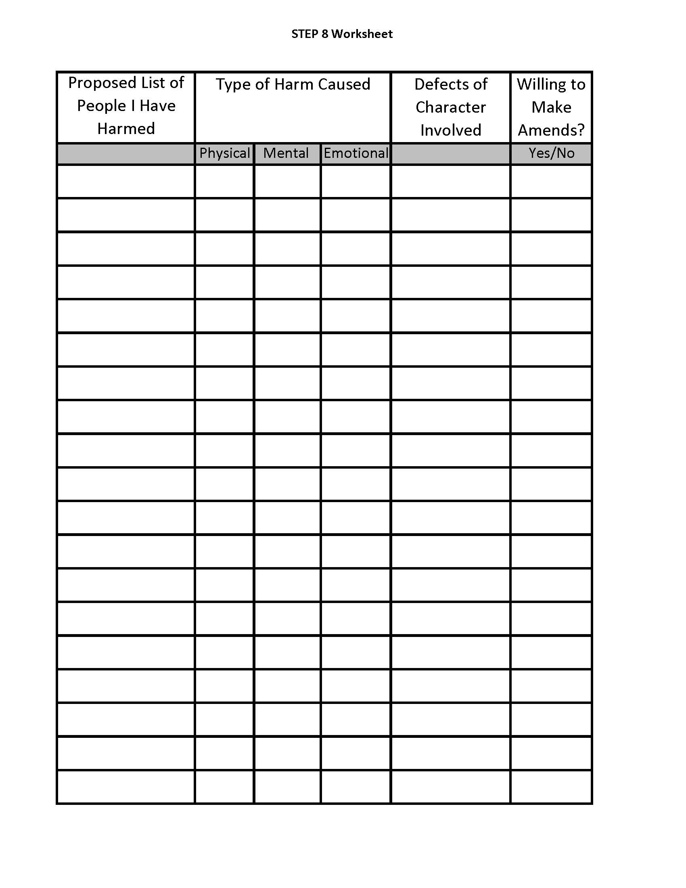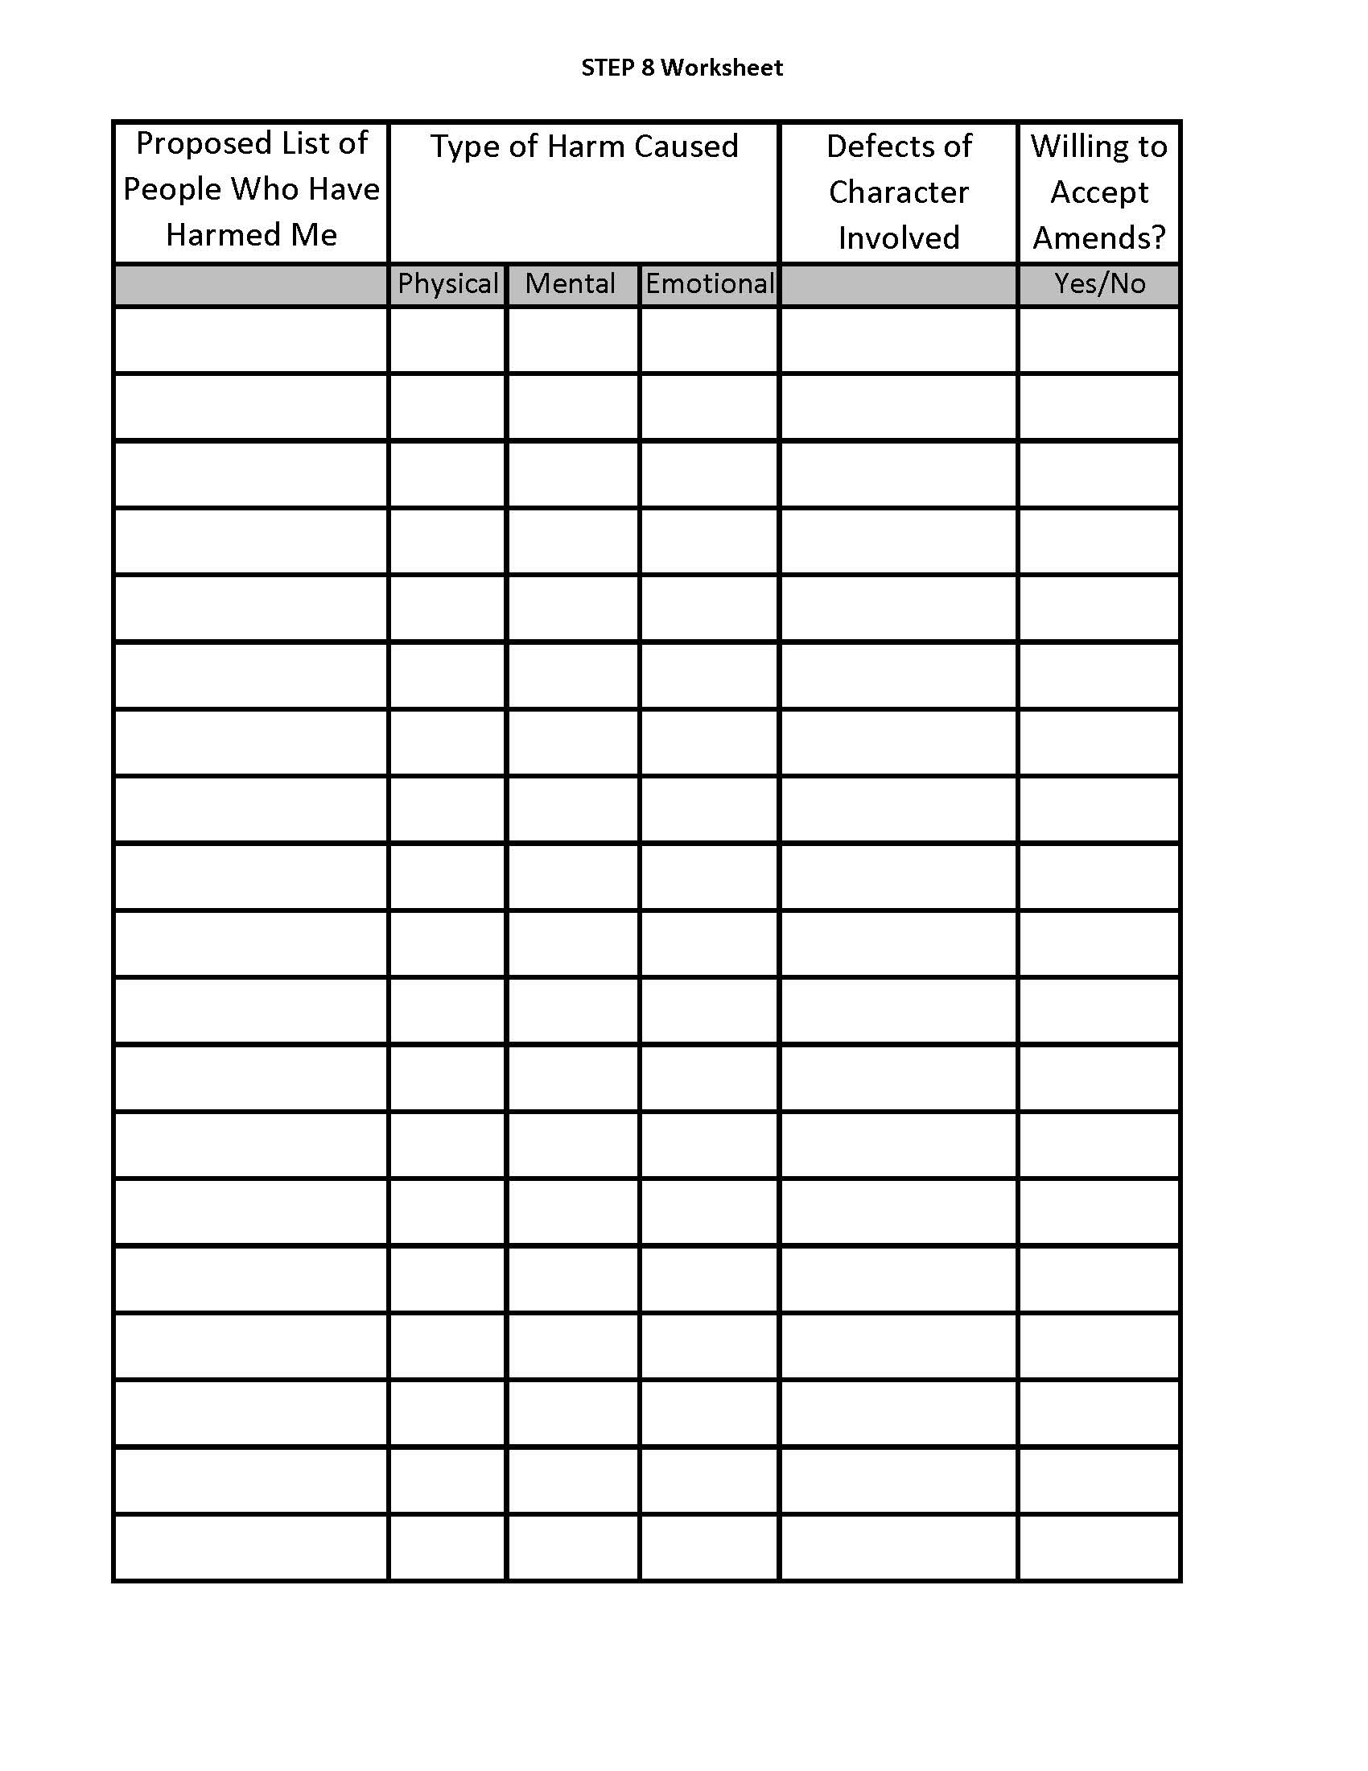
Step Nine
“We made direct amends to such people wherever possible, except when to do so would injure them or others.”
Part 1
1. It is suggested to read Step Nine out of NA Basic Text (5th or 6th Edition) every day before reflecting and writing.
2. It is suggested to read Step Nine out of It Works, How and Why (if available).
3. Reflect and write about your understanding of what it means “to make direct amends.” Then look it up and write about what you have learned.
4. Reflect and write what each part means to you:
- We made
- direct amends
- to such people
- wherever possible
- except when to do so
- would injure
- them or others
5. Review your list of people from the Eighth Step. Write how you would contact each entry on the list. Consider which people are priorities – according to your own criteria.
6. Think about and make notes about any people on the list that may be harmed by direct amends. How or why?
7. DO NOT TAKE ANY ACTION TO MAKE AMENDS without first talking with your Sponsor about doing so.
- - - - - - - - - - - - - - - - - -

“We made direct amends to such people wherever possible, except when to do so would injure them or others.”
This is the last and culmination of the cleansing and release steps. Making amends can be quite simple when we approach it with an attitude of positive expectancy. Many doors in our recovery will begin to open for us after we complete this step. Our growth will astound us. Knowing this alone will give us an attitude of positive expectancy.
We do exactly as this step says—we make direct amends to such people wherever possible.
Remember the first name we put on our list: our own. How do you make amends to our self? We must realize that we all started to make amends to ourselves the day we walked into the program. We continue to make amends to ourselves as we live the steps and carry the message of the program to other addicts. We can never give away more then we have received from the Program.
The next part of the step is "except when to do so would injure them or others". We must remember that sometimes in trying to make amends, the amends itself may injure the person we are trying to make amends to. As an example: in our addiction we may have injured someone by stealing from them. In verbally making amends, we may injure them by shocking them and causing them to have a resentment. We may want to handle this amend by reimbursing them in some way. It is important to go over each of our planned amends with our Sponsor to get guidance on how to make each of our amends so that we do not injure those people. When the steps refer to them or others remember that we too are one of those "others." We must make sure that the amends don’t injure us. That would be irresponsible as well. Again, be sure to go over the list and your intentions with your Sponsor.
What do we do regarding the nameless, faceless persons and institutions we listed as well? These can be addressed with an amends letter, read to your sponsor or another member. Your sponsor may have other ideas on how to make direct amends to the nameless and faceless.
One last word on the Ninth Step: many addicts would like to justify reasons why not to make amends including what others may have done to us. This is our disease talking. The step does not say others are to make amends to us, no matter what they did to us. This step tells us that WE are to make direct amends. Part of being in recovery is to recognize what we have control over our past, present, and future. We own our part in any problem, and we don’t try to assign an amount of blame to other parties.
Reflect and write about the following questions on a separate sheet of paper and consider sharing it with your Sponsor, another member, or another person.
1. What kind of attitude must we have when we do this step and why?
2. Why is it important to go over your list with your Sponsor?
3. Under certain circumstances, can amends injure someone?
4. How do you make amends to people you can't locate?
5. What awakening of consciousness (if any) did you have as a result of this step?

Step Ten
“We continued to take personal inventory and when we were wrong promptly admitted it.”
Part 1
1. It is suggested to read Step Ten out of the NA Basic Text (5th or 6th Edition) every day before reflecting and writing on this step.
2. It is suggested to read Step Ten out of It Works, How and Why (if available).
3. Write down your understanding of “taking personal inventory” and “when we were wrong promptly admitted it.” Compare your understandings to the readings.
4. Reflect and write what each part means to you:
- We continued
- to take personal inventory
- and when we were wrong
- promptly admitted it.
5. What are the core principle and purpose of Step Ten?
6. Every day, complete a personal inventory of events, actions, and feelings that took place during the day. Consider using the “10th Step Inventory” worksheet provided at the end of this section. Alternatively, each day write about events that happened—be they good or bad.
7. Consider (and look up) the term “promptly.” Reflect and write about how “promptly admitting our wrongs (to ourselves or others) could have or did help today.
- - - - - - - - - - - - - - - - - -
“We continued to take personal inventory and when we were wrong promptly admitted it.”
Step Ten is the first of the maintenance steps. By taking a daily inventory, we can eliminate the building up of many of the things we dealt with the Fourth through Ninth Steps. Step Ten It is a very important step because it helps us to embrace and carry out the Fourth Step (making a searching, fearless, and honest inventory) and Fifth Step (admitting the exact nature of our wrongs) on a daily basis.
We approach this step in two parts and the first part, "personal inventory" is divided in to two specific actions.
The first action is to reflect and review the major events of our day. We want to recognize and consider the way we handle things throughout the day, good and bad.
The second action of the personal inventory is to identify and focus on the things that we do not handle well and take a hard look at them. We use our understanding of the First Step (admitting that we were powerless over our addiction and that our lives had become unmanageable) and realize that we didn't handle some things well because of our addiction. We can then apply our Second Step understandings (came to believe the wisdom of the program and members could restore us to sanity) and consider how we could have handled the events differently. Finally, we add in the Third Step (we made a decision to follow a path of recovery) to help us handle things in a mature and responsible way.
Again, we see the importance and value of the first three steps in terms of understanding and carrying out the other steps.
The second part of Step Ten deals with understanding and acting on "when we were wrong, we promptly admitted it." There can be a lot of confusion about this part of Step Ten. Apologies are a part of it, but there is much more. "We promptly admitted it" applies to the self-honesty which is very important when we take our personal inventory. When we are wrong, we must promptly admit it to ourselves if we are going to do anything about it.
Addicts often go around telling everybody that we are sorry. This is not the answer!! Sorry means nothing if we continue doing the same thing over and over again. We must use self-honesty to admit our wrongs to ourselves, face those wrongs, and then apply the first three steps to our situation. This takes practice, practice and more practice. To learn to live the steps, we must practice the steps. We should not strive for perfection, but we should strive to practice these steps every day.
Another common question about this step is, "is this step done mentally or is it done with pen and paper?" Those experienced in the program advise that in the beginning it really should be done through writing. Later, as we gain more experience with practicing the step, we will find it becomes a part of our everyday lives and writing down every event is less necessary.
Part 2
Reflect and write about the following questions on a separate sheet of paper.
1. What is a personal inventory?
2. How do we do a personal inventory?
3. "When we were wrong, promptly admit it," what does this mean?
4. In what ways do the first three steps apply to the Tenth Step?
5. Why is the Tenth Step necessary?
6. What awakening of consciousness or understanding did you have as a result of this step?

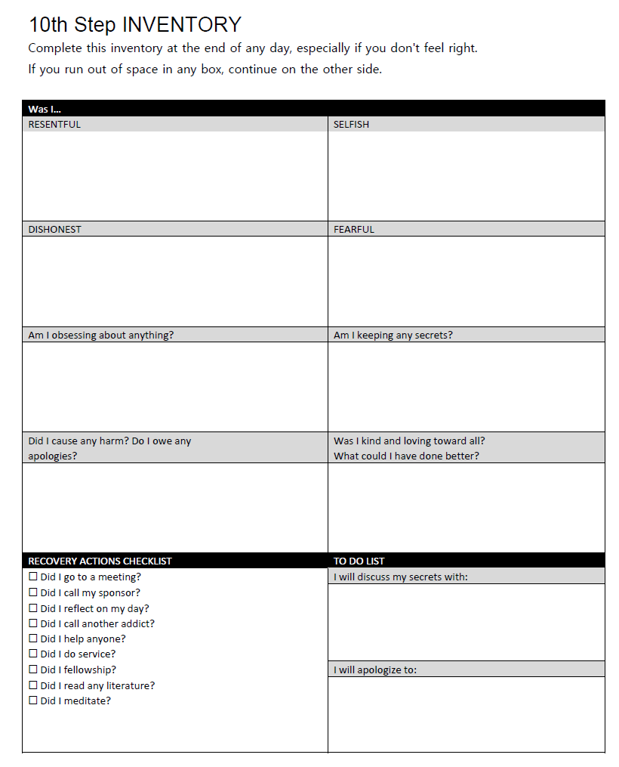
Step Eleven
“We sought through meditation to improve our conscious contact with our highest selves and to find integrity in all areas of our lives.”
Part 1
1. It is suggested to read Step Eleven out of the NA Basic Text (5th or 6th Edition) every day before reflecting and writing.
2. It is suggested to read Step Eleven out of It Works, How and Why (if available).
3. Write down your definition of each word in the step. Then look up each word individually in the dictionary and write down what you learn about the difference between what you thought the words meant and the dictionary definitions.
4. Write what each part means to you:
- We sought
- through meditation
- to improve
- our conscious contact
- with our higher selves
- and to find integrity
- in all areas of our lives.
5. What is the principle of Step Eleven?
6. What is “meditation” and what are some of the various ways to practice meditation?
7. What are some ways you can prepare yourself for meditation?
8. How would you describe your “highest self”?
9. What does integrity mean to you?
- - - - - - - - - - - - - - - - - -
“We sought through meditation to improve our conscious contact with our highest selves and to find integrity in all areas of our lives.”
Here in the Eleventh Step all the work we put into the steps seems to come together. As we learned to do and live the Tenth Step every day, we have been putting integrity back in our lives—even though we may not have been aware of it.
Our starting point here in Step Eleven is to learn to calm our minds and concentrate on” being still.” The program is not about telling you how to meditate. Meditation is a technique that can take many different forms. Our approach to meditation is decided by each of us in the way we feel comfortable. We offer some examples of meditation approaches only as a possible place to start. Ultimately, we each develop our own way. We will know which way is most comfortable for us by the way we feel. A feeling of serenity and easing of stress will tell us.
Here are some examples of how some addicts meditate.
1. Lying or sitting and just getting a feeling of serenity and bathing in it.
2. Walking and feeling serene by getting in touch with nature around us.
3. Sitting and looking at a picture of a beautiful scene or seeing the scene in their mind and getting serene and at peace.
4. Using one of the many meditation techniques of quiet, slow breathing and repeating a mantra for 20 minutes.
There is no set way to meditate. Meditation is the listening part. Meditation is necessary. If we had a friend who did the talking all the time and never took time to hear us, eventually they would no longer be our friend. As we practice the program principles in our lives, the core of our disease--self-centeredness—can be arrested, and we will then begin to act in more mature and responsible ways in all our affairs.
Part 2
Reflect and write the following on a separate piece of paper.
1. What is meditation?
2. Why is meditation important?
3. Is there any certain way to meditate?
4. Where are some areas that integrity fit in to your life?
5. Are there any areas that you feel integrity has not been a part of your actions in these areas?
6. What awakening of understanding or consciousness did you have as a result of this step?

Step Twelve
“Having had an awakening as a result of these steps, we tried to carry this message to addicts and to practice these principles in all our affairs.”
Part 1
1. It is suggested to read Step Twelve out of the NA Basic Text (5th or 6th Edition) every day before reflecting and writing.
2. It is suggested to read Step Twelve out of It Works, How and Why.
3. Write down your definition of each word in the step. Then look up each word individually in the dictionary and write down what you learn about the difference between what you thought it meant and the dictionary says it means.
4. Write what each part means to you:
- Having had
- an awakening
- as a result
- of these steps
- we tried
- to carry
- this message
- to addicts
- and to practice
- these principles
- in all our affairs.
5. What is the principle of Step Twelve?
6. Every day write on events that happened where you "Practiced these principles".
This step gives us direction for what we must do in our affairs. The awakening as a result of these steps is very simple. The awaking is that the steps work and that we must carry the message that they work to other addicts. The awaking also tells us that we must practice these principles in all our affairs.
- - - - - - - - - - - - - - - - - -
“Having had an awakening as a result of these steps, we tried to carry this message to addicts and to practice these principles in all our affairs.”
Very simply this step tells me to carry the message of the steps—to live them in my life and to help others who also suffer. “Carry the message” also means that I must give back to the program so the program can share the message and power of the program to other addicts. If I am to live the steps, it means that I must get involved in service in some way. I no longer have an excuse. Becoming clean and sober is not the end; it is a beginning of a new way of life. There is never an end to learning the steps. It is a lifetime journey.

Part 2
Reflect and write about the following on a separate piece of paper.
1. What is the “awakening?”
2. How does the Twelfth Step tell us to get involved?
3. After reaching the Twelfth Step, what’s next? Are we done? Cured? Is this the end?
4. What is the message that we carry to addicts?
5. What are some of the ways that we can carry the message to addicts?
6. What awakening of awareness or consciousness did you have as a result of this step?

